

WIREFRAMES

UEE- Milestone – 04



October 16, 2022

BIKO

TEA COLLECTOR APP

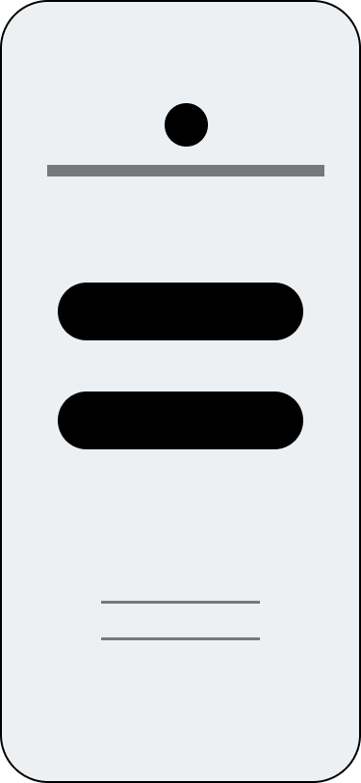 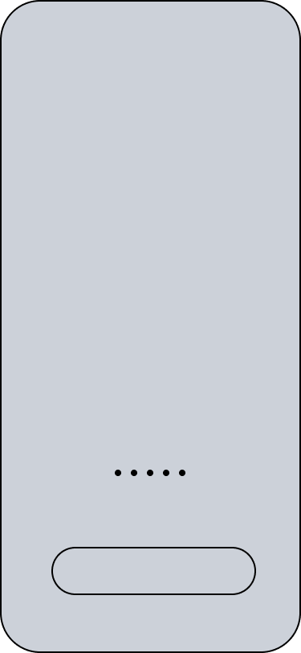

Welcome page

Get Started Page

Login Page

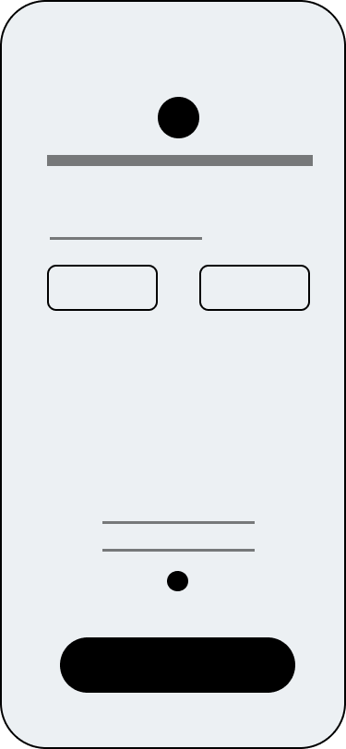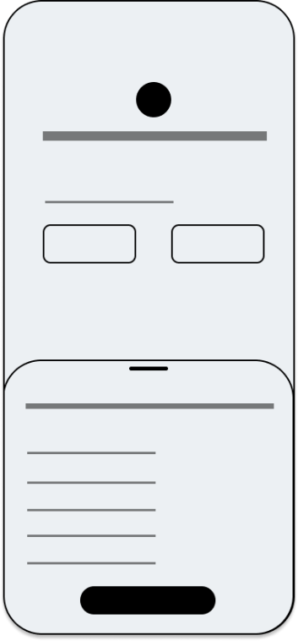0

How to create a PIN

Create PIN Page

Registration Page

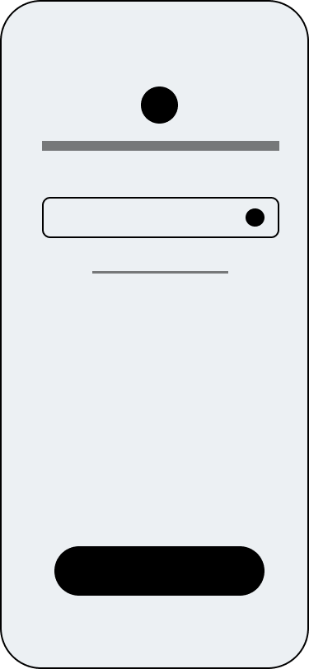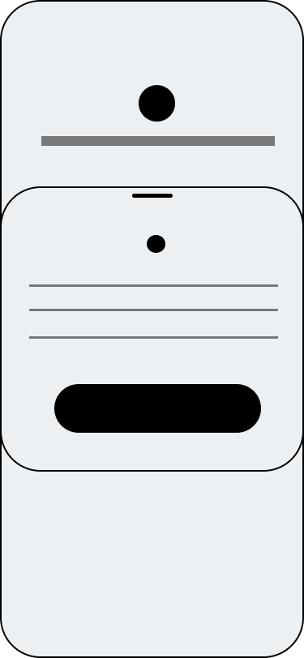

Enter PIN Number

Prompt unsuccess message

Prompt Success message

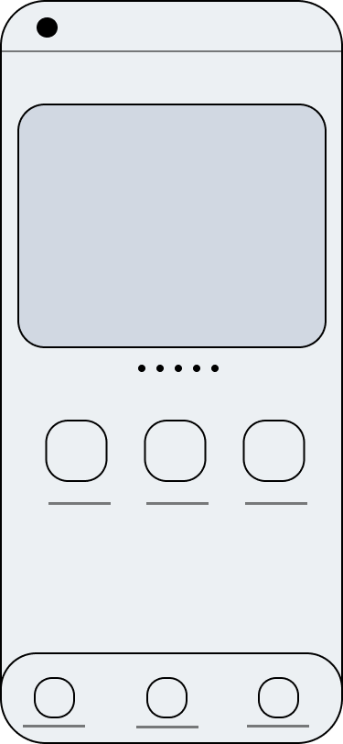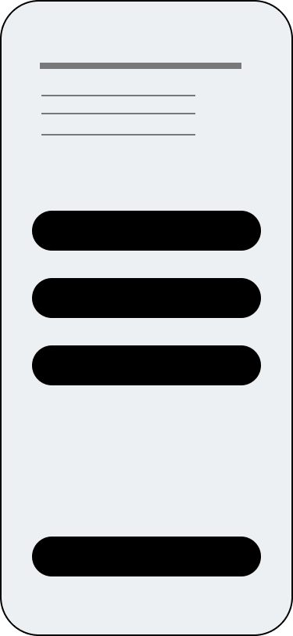

Tea Seller Dashboard

Prompt login unsuccess message

Contact US for forgot PIN

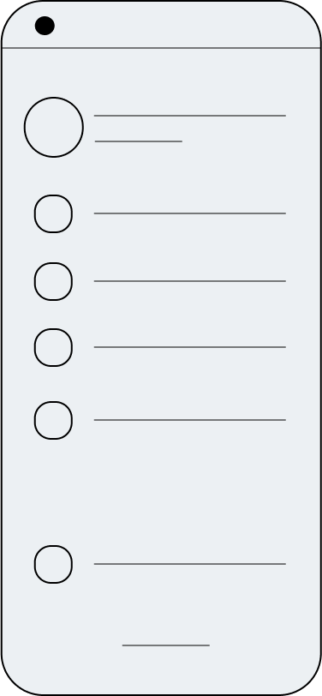

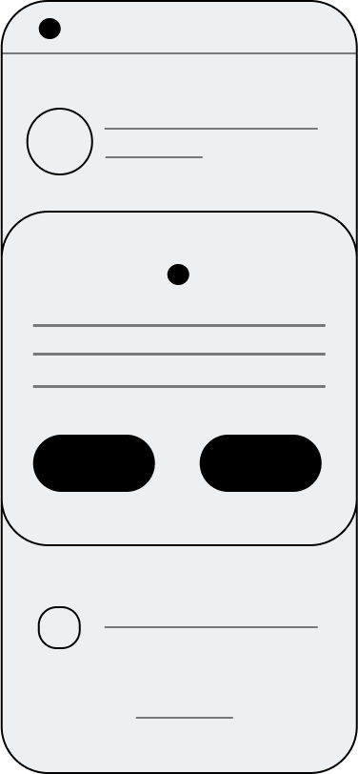

My Profile

Logout Confirmation

Menu Bar

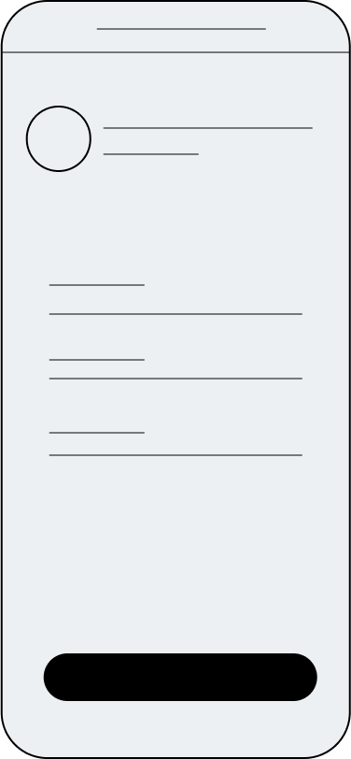

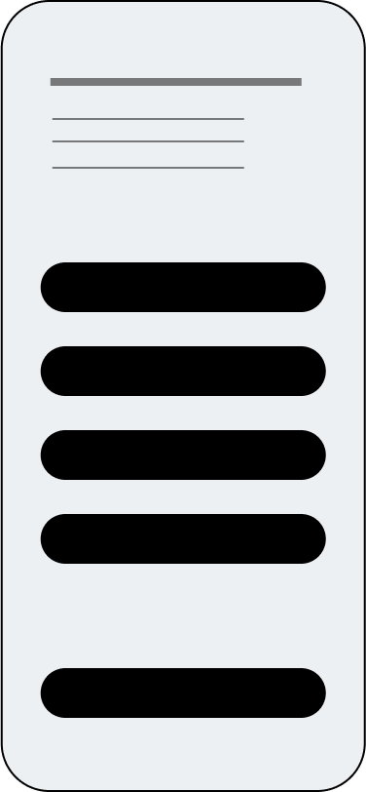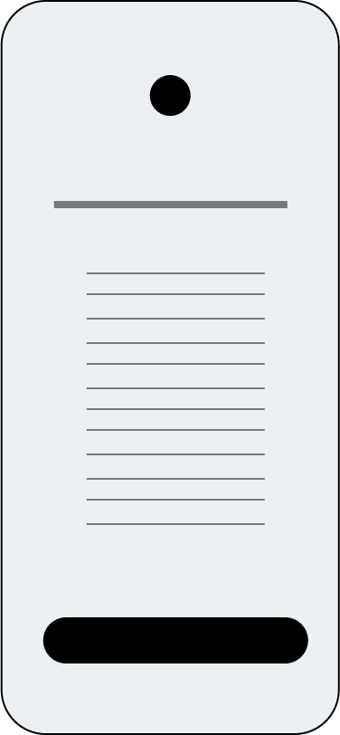

WhatsApp | Google Map

Contact US

Terms and Conditions

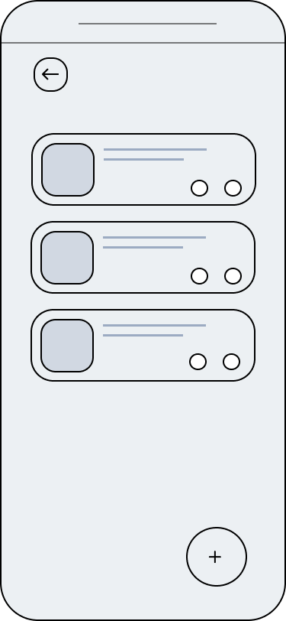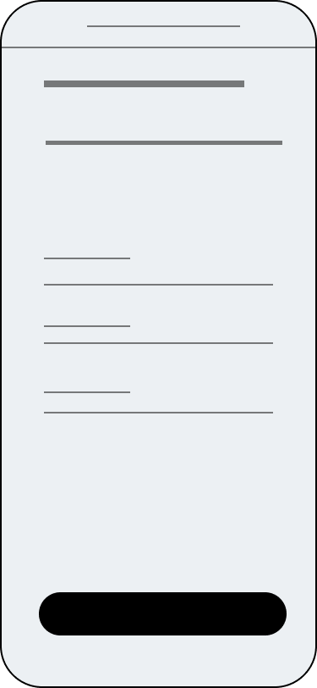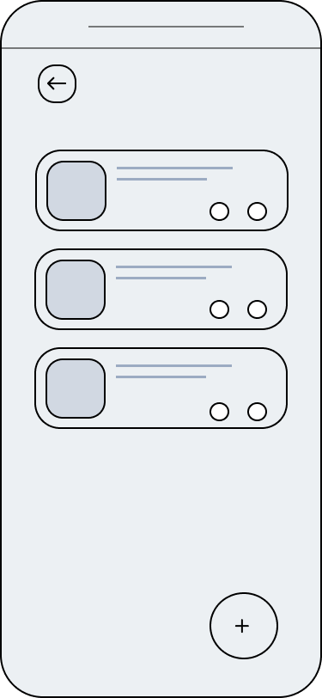

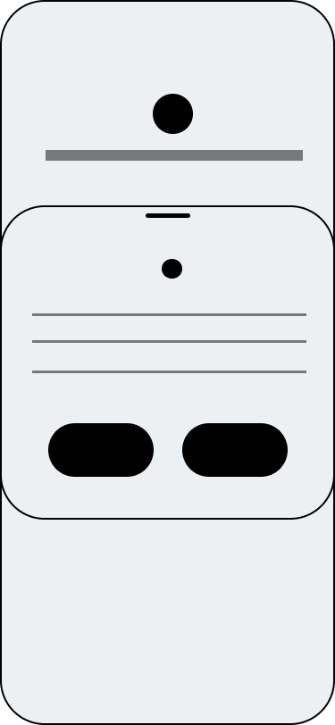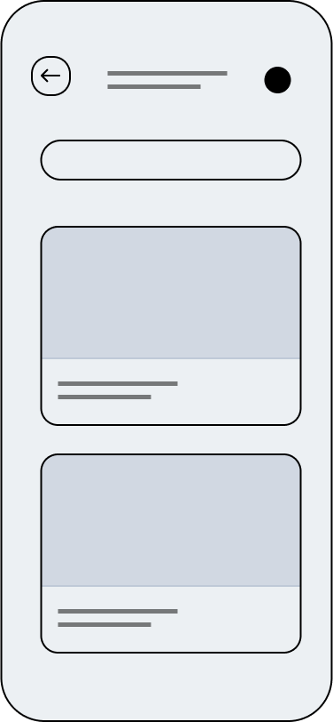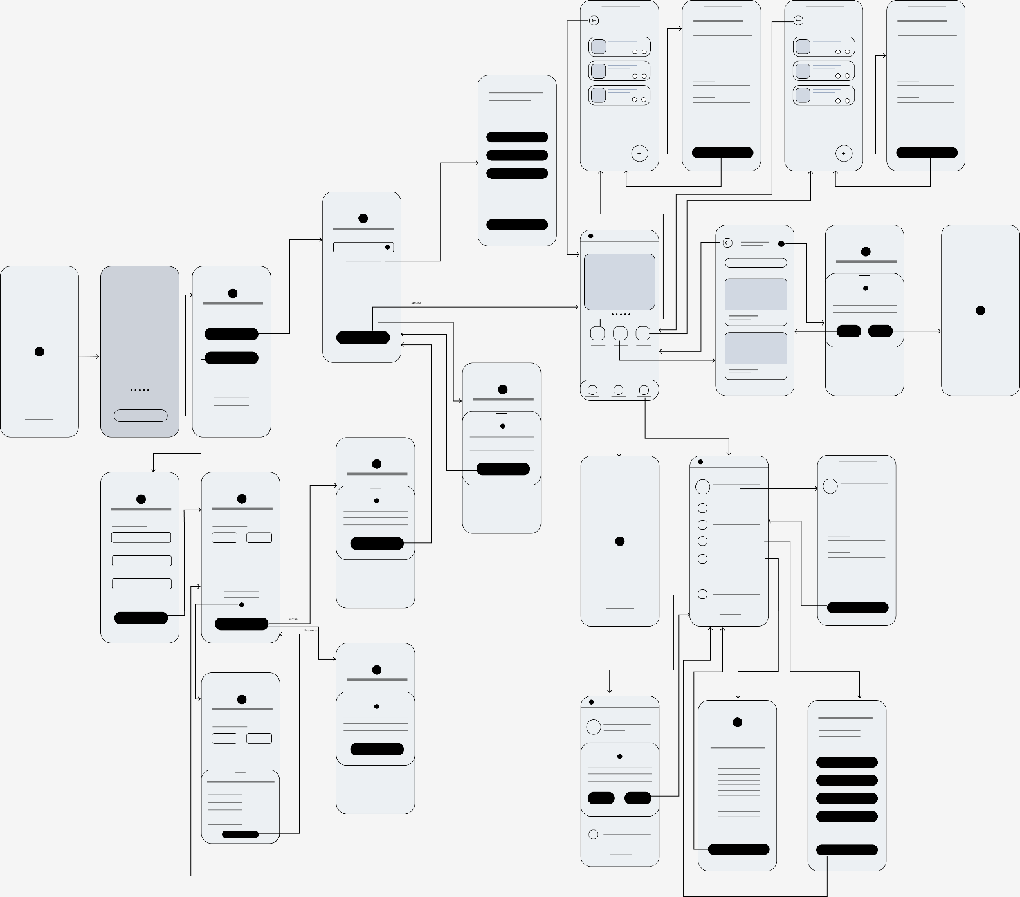Figma Link 🡪 <https://www.figma.com/file/MKnJNSgGYhHt9YQzVS5RUw/Untitled>

Add Tea Diary Details Page

Access Granted Pop-up message

View Timetable Details

View Web Tea Diary Page

Add Lorry Request Page

View Tea Lorry Request Page